***Steps I follow to Download Android Studio:-***

1. First I visit the official Android Studio website at <https://developer.android.com/studio>.
2. Then I click on the "Download Android Studio" button and choose the Android Studio version which is compatible with my Windows.
3. After that, I click the "Download" button to start the download process.
4. Once the download is complete, locate the installation file and double-click on it to start the installation process.
5. Follow the instruction on the screen to complete the installation process. This will involve the License agreement and choosing the installation directory.
6. Once the installation is complete, launch Android Studio and start using it.

Here is the snapshot of the Android Studio working on my system

Fig 1: Loading Screen

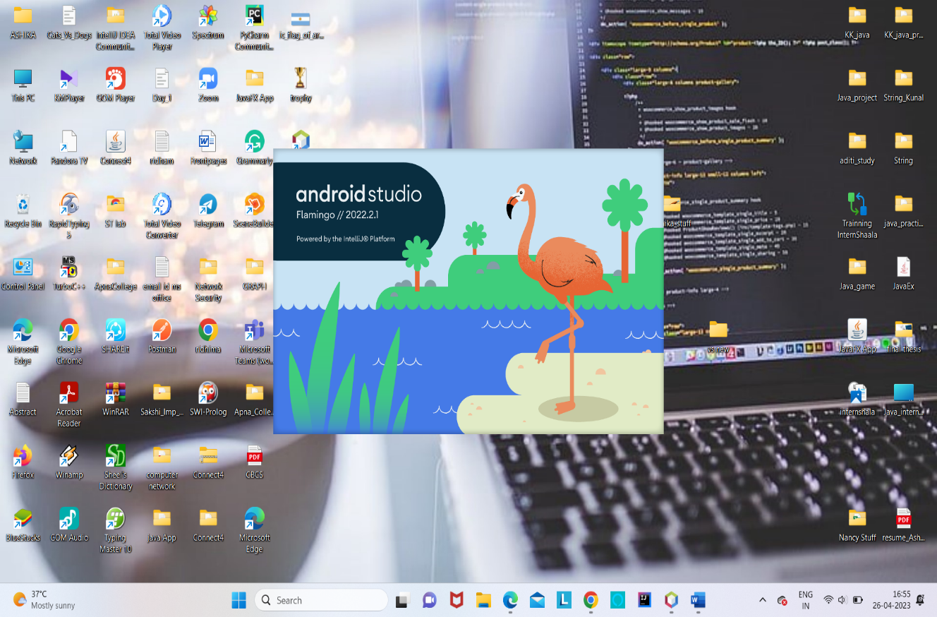

Fig 1:Loading Screen

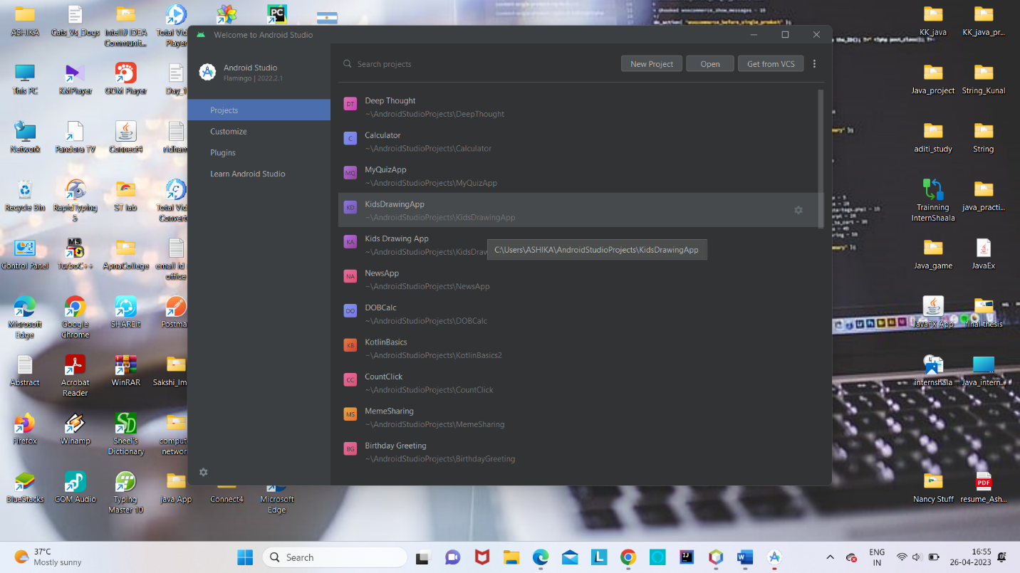

Fig 2: Welcome Screen